**VEHICLE SHOWROOM MANAGEMENT SYSTEM**

Project submitted to the

SRM University – AP, Andhra Pradesh

for the partial fulfillment of the requirements to award the degree of

**Bachelor of Technology/Master of Technology**

In

**Computer Science and Engineering**

**School of Engineering and Sciences**

Submitted by

**Shaik. Faiyajuddin**

**(AP20110010363)**

Under the Guidance of

**(Dr.Rajiv Senapati sir)**

**SRM University–AP**

**Neerukonda, Mangalagiri, Guntur**

**Andhra Pradesh – 522 240**

**[Month, Year]**

# Certificate

Date: 17-Dec-22

This is to certify that the work present in this Project entitled “**VEHICLE SHOWROOM MANAGEMENT SYSTEM**” has been carried out by **Shaik. Faiyajuddin** under my/our supervision. The work is genuine, original, and suitable for submission to the SRM University – AP for the award of Bachelor of Technology/Master of Technology in **School of Engineering and Sciences**.

**Supervisor**

(Signature)

Prof. / Dr. Rajiv Senapati Sir

Designation,

Affiliation.

# Acknowledgements

We thank Dr.Rajiv Senapati sir, our professor in charge, for the help and direction in finishing our project on the subject Database Management System. It was a fantastic learning oportunity.This subject has given me an opportunity to explore the field I have always been curious about. Your insightful counsel and recommendations were quite beneficial to me as I finished the assignment. I will always be grateful to you sir for this.

# Table of Contents

Certificate i

Acknowledgements iii

Table of Contents v

Abstract vii

1. Introduction 1

2. Methodology 3

2.1 Identification of list of Entities 3

2.2 Identification of Attributes of Entities 3

2.3 Identification of relationship between Entities…………………………………4

2.4 E-R Model …………………………………………………………………………5

2.5 Relational Model……………………………………………………………….....6

2.6 Normalization………………………………………………………………….....7

3. SQL Code………………………………………………………………………………18

3.1 SQL Queries……………………………………………………………………….......35

4 Conclusion………………………………………………………………………………38

5. Future Work…………………………………………………………………………….40

References…………………………………………………………………………………42

# Abstract

This project is basically about creating a database management system for managing a vehicle showroom . Aim of the project is to create a backend program of the processes taking place using SQL. This model deals with the relationship between the customer, Vehicle and Showroom. The other entities play a supportive weak role. So, this helps the showroom to keep record of vehicles sold to the customer and also keep the record of the vehicles available.

Regarding the registration module, it contains the information about new customers details like name of the customer, customer details etc. Vehicle Details module contains the details like Name of the Vehicle, send from, send to etc. Billing and Payment Detail will contain the details like Actual Amount to be paid, emi. Searching is having the details of the customer. Manager can search the details of the customer it will show all details like customer Details, vehicle name, payment type etc. This "Vehicle Showroom Management System" project mainly contains the vehicle information, customer details and loan recovering details.

# Introduction

This is a live project which was developed for a local Vehicle Showroom. It is useful to the manager to maintain the Customers details, sales Details, Showroom items, services and also Vehicle Details. If any customer buy a vehicle in loan that persons vehicle will recognizes with the help of vehicle_ID. Vehicle Recognition System, which will cover the following modules. The manager will enter the vehicle No It will help the user to search the vehicle details and the required details of the customer. The manager enters the customer details and maintain showroom details.

Vehicle showroom management system is ideal for dealers or resellers of any size. The vehicle showroom control panel can be installed on any Operating System. The product features include: easy stock inventory updates, full user management, marketing reports, and easy to access.

# Methodology

**2.1 Identification of list of Entities:**

1. MANAGER

2. DEALER

3. SHOWROOM

4. VEHICLE

5. SALES

6. CUSTOMER

7. WORKER

8. BOOKING

9. PAYMENT

10. BILLING

11. TAX



## 2.2 Identification of Attributes of Entities:

**MANAGER:** (MANAGER_ID, MFIRST_NAME, MMIDDLE_NAME, MLAST_NAME, MANAGER_QUALIFICATION , MANAGER_D.O.B, LOCATION, CITY, STATE, MANAGER_CONTACT ,GENDER)

**DEALER:** (DEALER_ID, DFIRST_NAME, DMIDDLE_NAME, DLAST_NAME, LOCATION, CITY, STATE, GENDER, DEALER_CONTACT)

**SHOWROOM:** (SHOWROOM_ID, SHOWROOM_NAME, LOCATION, CITY, STATE, SHOWROOM_CONTACT)

**VEHICLE**: (VEHICLE_ID, VEHICLE_NAME, VEHICLE_TYPE, VEHICLE_COST, VEHICLE_DESCRIPTION, CREATE_DATE, STATUS, VEHICLE_MODEL)

**SALES**: (SALES_ID, COST, SALES_DESCRIPTION, ORDER_DATE, DELIVARY_DATE, CITY, STATE)

**CUSTOMER**: (CUSTOMER_ID, CFIRST_NAME, CMIDDLE_NAME, CLAST_NAME, LOCATION, CITY, STATE, GENDER, CUSTOMER_CONTACT, CUSTOMER_EMAILID)

**WORKER**: (WORKER_ID, WFIRST_NAME, WMIDDLE_NAME, WLAST_NAME, WORKER_TYPE, WORKER_SALARY, GENDER, WORKER_DESCRIPTION, WORKER_CONTACT)

**BOOKING**: (BOOKING_ID, BOOKING_DATE, BOOKING_PAYMENT, AMOUNT, BOOKING_TYPE)

**PAYMENT**: (PAYMENT_ID, PAYMENT_DATE, PAYMENT_AMOUNT, PAYMENT_TYPE, STATUS)

**BILLING**: (BILLING_ID, BILLING_DATE, BILLING_AMOUNT, TAX_AMOUNT)

**TAX**: (TAX_ID, TAX_AMOUNT, TAX_TYPE, STATUS)

### 2.3 Identification of relationship between the Entities:

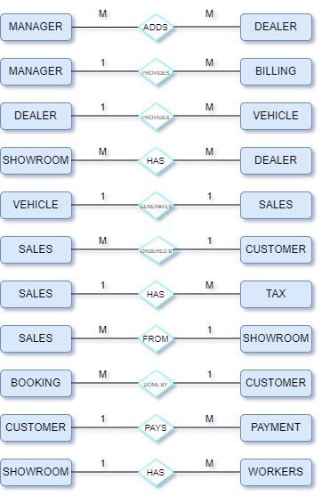

**2.4 E-R Model:**

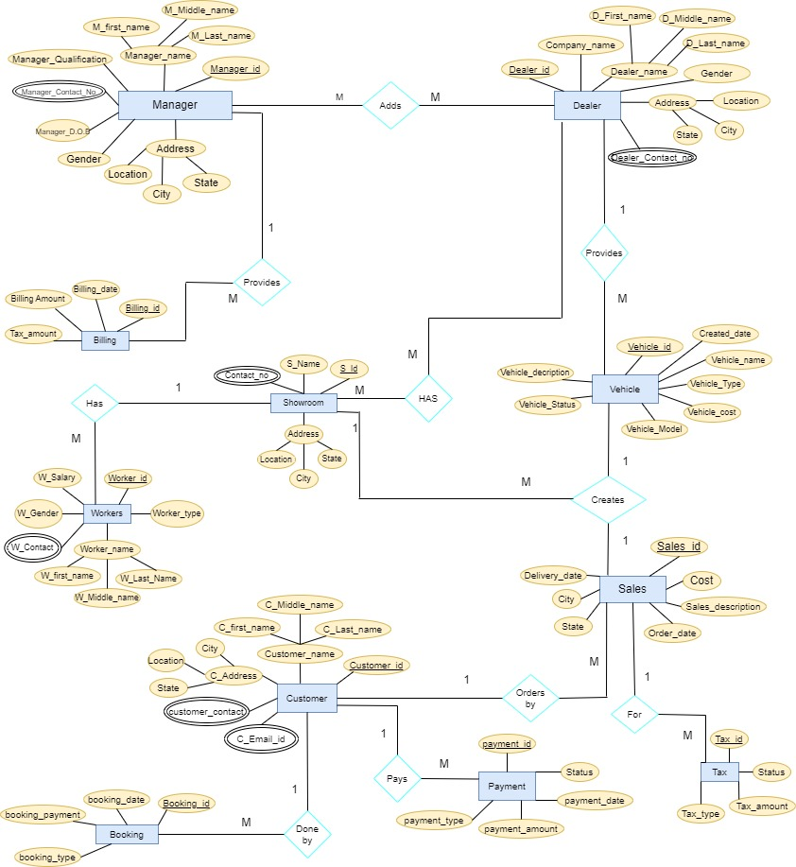

**2.5 Relational Model:**

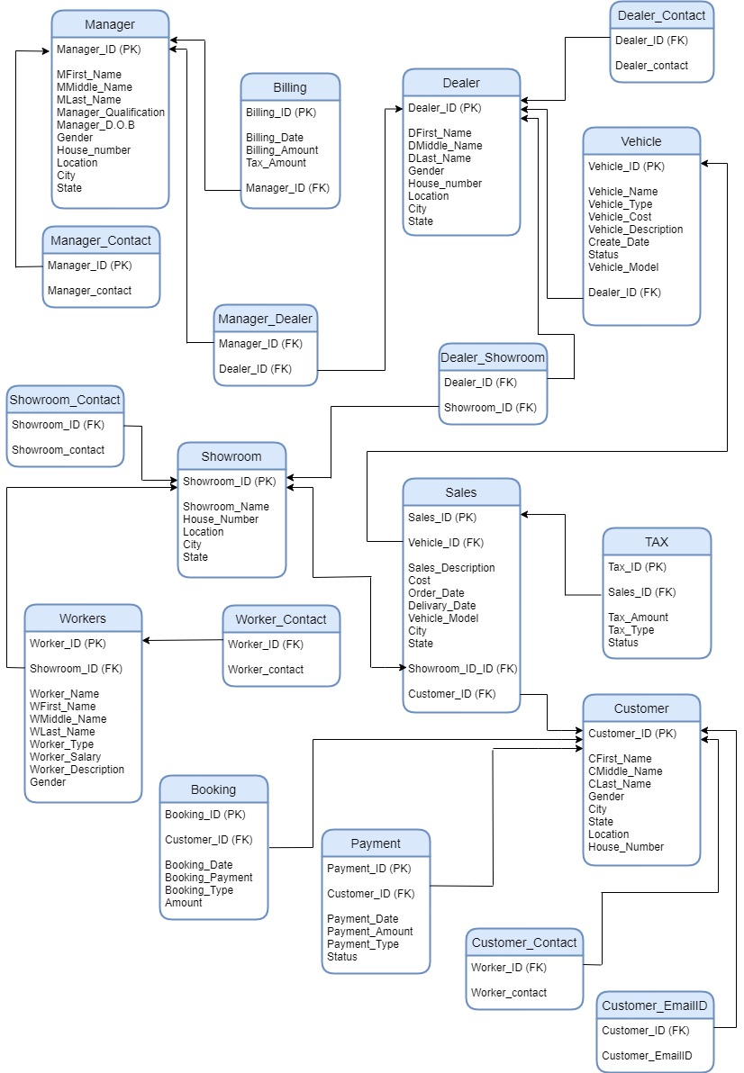

**2.6 Normalization:**

**Manager Table:**

Attributes.'-

Manager-ID, Mfirst_name, Mmiddle_name, Mlast-name, Manager_qualification, Manager-DOB, House-number, Location, City, State.

functional Dependencies:-

Manager – ID 🡪 Mfirst_name

Manager ID 🡪 Mmiddle_name

Manager ID 🡪 Mlast_name

Manager ID 🡪 Manager_qualification

Manager-ID 🡪 Manager_D.O.B

Manager-ID 🡪 House_number

Manager-ID 🡪 Location

Manager-ID 🡪 City

Manager-ID 🡪 State

Manager-ID 🡪 Gender

Primary Key: Manager_ ID

**First Normal Form(1NF):**

CONDITION: If a relation is said to be in 1NF only if it has no non atomic attributes in it.

The table is already in First Normal Form because there are no non atomic attributes present in it.

Manager-ID, Mfirst_name, Mmiddle_name, Mlast-name, Manager_qualification, Manager-DOB, House-number, Location, City, State attributes are atomic attributes. So, the relation satisfies 1NF.

**Second Normal Form(2NF):**

If a relation is said to be in 2NF then the relation should be in 1NF and should satisfy any one of the below conditions.

CONDITIONS: 1. If the primary key consists of only one attribute.

2.If there exists no non key attributes.

3. Every non key attribute present in the relation should be fully functionally dependent on the full set of the primary key.

The table is already in 2NF because it is 1NF and satisfies the first condition of the second normal form. The relation has only one attribute as Primary key in it (Manager_ ID).

**Third Normal Form(3NF):**

CONDITION: If a relation is said to be in 3NF only if the relation is in 1NF, 2NF & it has no transitive functional dependency in it.

The table is already in 3NF because it is in 1NF, 2NF and there is no transitive functional dependency in the table. Manager-ID, Mfirst_name, Mmiddle_name, Mlast-name, Manager_qualification, Manager-DOB, House-number, Location, City, State attributes have no transitive functional dependency between them. So, the relation satisfies the 3NF.

**Fourth Normal Form(4NF):**

If a relation is said to be in fourth normal form(4NF) only if it has no multivalued dependencies.

The table is already in 4NF because it has no multivalued dependencies. Manager-ID, Mfirst_name, Mmiddle_name, Mlast-name, Manager_qualification, Manager-DOB, House-number, Location, City, State attributes in the relation are single valued attributes. So, it satisfies the 4NF.

**Billing Table:**

Attributes:

Billing_ID, Billing_amount, Billing_date, Tax_amount

Functional Dependencies:

Billing_ID 🡪 Billing_date

Billing_ID 🡪 Billing_amount

Billing_ID 🡪 Tax_amount

Primary Key: Billing_ID

**First Normal Form(1NF):**

The table is already in 1NF because the table has no non atomic attributes present in it. Billing_ID, Billing_amount, Billing_date, Tax_amount are atomic attributes. So, the relation satisfy the 1NF.

**Second Normal Form(2NF):**

The Table is already in 2NF because the table is in 1NF & it satisfies the first condition of the second normal form. The relation has only one attribute as Primary key in it (Billing_ ID). So, it satisfy the 2NF.

**Third Normal Form(3NF):**

The table is already in 3NF because the table is in 1NF, 2NF & it has no transitive functional dependency in it. Billing_ID, Billing_amount, Billing_date, Tax_amount has no transitive functional dependency between them. So, it satisfies the 3NF.

**Fourth Normal Form(4NF):**The table is already in 4NF because it has no multivalued dependency present in it. Billing_ID, Billing_amount, Billing_date, Tax_amount are single valued attributes. So, the relation satisfies the 4NF.

**Vehicle Table:**

Attributes:

Vehicle_ID, Vehicle_Type, Vehicle_cost, Vehicle_description, Create_date, Status, Vehicle_model

Functional Dependencies:

Vehicle_ID 🡪 Vehicle_Type

Vehicle_ID 🡪 Vehicle_cost

Vehicle_ID 🡪 Vehicle_description

Vehicle_ID 🡪 Vehicle_model

Vehicle_ID 🡪 Create_date

Vehicle_ID 🡪 Status

Primary Key: Vehicle_iD

**First Normal Form(1NF):**

The table is already in 1NF because the table has no non atomic attributes present in it. Vehicle_ID, Vehicle_Type, Vehicle_cost, Vehicle_description, Create_date, Status, Vehicle_model are atomic attributes. So, it satisfies 1NF.

**Second Normal Form(2NF):**

The table is already in 2NF because the table is in 1NF & has only one attribute as a Primary key in it.

The relation has only one attribute (Vehicle_ID) as a Primary key. So, it satisfy the 2NF

**Third Normal Form(3NF):**

The table is already in 3NF because the table is in 1NF, 2NF & has no transitive functional dependency among the attributes. Vehicle_ID, Vehicle_Type, Vehicle_cost, Vehicle_description, Create_date, Status, Vehicle_model has no transitive functional dependency between them. So, the relation satisfies the 3NF.

**Fourth Normal Form(4NF):**

The table is already in 4NF because it has no multivalued dependency in it. Vehicle_ID, Vehicle_Type, Vehicle_cost, Vehicle_description, Create_date, Status, Vehicle_model attributes are single valued attributes. So, it satisfies the 4NF.

**Sales Table:**

Attributes:

Sales_ID, cost, Sales_description, Order_date, Delivary_date, city, state

Functional Dependencies:

Sales_ID 🡪 cost

Sales_ID 🡪 Sales_description

Sales_ID 🡪 Order_date

Sales_ID 🡪 Delivary_date

Sales_ID 🡪 city

Sales_ID 🡪 state

Primary Key: Sales_ID

**First Normal Form(1NF):**

The table is already in 1NF because the table has no non atomic attributes in it. Sales_ID, cost, Sales_description, Order_date, Delivary_date, city, state attributes are atomic attributes. So, the relation satisfies 1NF.

**Second Normal Form(2NF):**

The table is already in 2NF because the table is in 1NF & has only one attribute(Sales_ID) as Primary Key in it which satisfies the first condition of 2NF. So, the relation satisfy the 2NF.

**Third Normal Form(3NF):**

The table is already in 3NF because the table is in 1NF, 2NF & has no transitive functional dependency among the attributes. Sales_ID, cost, Sales_description, Order_date, Delivary_date, city, state attributes has no transitive functional dependency between them. So, they satisfy the 3NF.

**Fourth Normal Form(4NF):**

The table is already in 4NF because it has no multivalued dependency in it. Sales_ID, cost, Sales_description, Order_date, Delivary_date, city, state attributes are single valued attributes. So, they satisfy the 4NF.

**Showroom Table:**

Attributes:

Showroom_ID, Showroom_Name, Location, city, state

Functional Dependencies:  
Showroom_ID 🡪 Showroom_Name

Showroom_ID 🡪 Location

Showroom_ID 🡪 city

Showroom_ID 🡪 State

Primary Key: Showroom_ID

**First Normal Form(1NF):**

The table is already in 1NF because the table has no non atomic attributes in it. Showroom_ID, Showroom_Name, Location, city, state attributes are atomic attributes so, the relation satisfies the 1NF.

**Second Normal Form(2NF):**

The table is already in 2NF because the table is in 1NF & has only one attribute(Showroom_ID) as primary key in it which satisfies the first condition of 2NF.

**Third Normal Form(3NF):**

The table is already in 3NF because the table is in 1NF, 2NF & has no transitive functional dependency among the attributes. Showroom_ID, Showroom_Name, Location, city, state attributes has no transitive functional dependency between them. So, the relation satisfies the 3NF.

**Fourth Normal Form(4NF):**

The table is already in 4NF because it has no multivalued dependency in it. Showroom_ID, Showroom_Name, Location, city, state attributes are single valued attributes so, the relation satisfies the 4NF.

**Worker_Table:**

Attributes:

Worker_ID, Wfirst_name, Wmiddle_name, Wlast_name, Worker_type, Worker_salary, Worker_description, Gender.

Worker_ID 🡪 Wfirst_name

Worker_ID 🡪 Wmiddle_name

Worker _ID 🡪 Wlast_name

Worker _ID 🡪 Worker_type

Worker _ID 🡪 Worker_salary

Worker _ID 🡪 Worker_description

Worker _ID 🡪 Gender

Primary Key: Worker_ID

**First Normal Form(1NF):**

The table is already in 1NF because the table has no non atomic attributes in it. Worker_ID, Wfirst_name, Wmiddle_name, Wlast_name, Worker_type, Worker_salary, Worker_description, Gender attributes are atomic attributes so, the relation satisfies the 1NF.

**Second Normal Form(2NF):**

The table is already in 2NF because the table is in 1NF & has only one attribute(Worker_ID) as primary key in it which satisfies the first condition of 2NF.

**Third Normal Form(3NF):**

The table is already in 3NF because the table is in 1NF, 2NF & has no transitive functional dependency among the attributes Worker_ID, Wfirst_name, Wmiddle_name, Wlast_name, Worker_type, Worker_salary, Worker_description, Gender attributes has no transitive functional dependency between them. So, the relation satisfies the 3NF.

**Fourth Normal Form(4NF):**

The table is already in 4NF because it has no multivalued dependency in it. Worker_ID, Wfirst_name, Wmiddle_name, Wlast_name, Worker_type, Worker_salary, Worker_description, Gender attributes are single valued attributes so, the relation satisfies the 4NF.

**Booking Table:**

Attributes:

Booking_ ID, Booking_ date, Booking_ payment, Amount, Booking _type

Functional Dependencies:

Booking _ID 🡪 Booking _date

Booking _ID 🡪 Booking _payment

Booking _ID 🡪 Booking _type

Booking _ID 🡪 Amount

Primary Key: Booking _ID

**First Normal Form(1NF):**

The table is already in 1NF because the table has no non atomic attributes in it. Booking_ ID, Booking_ date, Booking_ payment, Amount, Booking _type attributes are atomic attributes so, the relation satisfies the 1NF.

**Second Normal Form(2NF):**

The table is already in 2NF because the table is in 1NF & has only one attribute (Booking_ID) primary key in it which satisfies the first condition of 2NF.

**Third Normal Form(3NF):**

The table is already in 3NF because the table is in 1NF, 2NF & has no transitive functional dependency among the attributes. Booking_ ID, Booking_ date, Booking_ payment, Amount, Booking _type attributes has no transitive functional dependency between them. So, the relation satisfies the 3NF.

**Fourth Normal Form(4NF):**

The table is already in 4NF because it has no multivalued dependency in it. Booking_ ID, Booking_ date, Booking_ payment, Amount, Booking _type attributes are single valued attributes so, the relation satisfies the 4NF.

**Payment Table:**

Attributes:

Payment_ ID, Payment_ date, Payment_ Amount, Payment_ type, Status

Functional Dependencies:

Payment _ID 🡪 Payment _date

Payment _ID 🡪 Payment _Amount

Payment _ID 🡪 Payment _type

Payment _ID 🡪 Status

Primary Key: Payment _ID

**First Normal Form(1NF):**

The table is already in 1NF because the table has no non atomic attributes in it. Payment_ ID, Payment_ date, Payment_ Amount, Payment_ type, Status attributes are atomic attributes so, the relation satisfies the 1NF.

**Second Normal Form(2NF):**

The table is already in 2NF because the table is in 1NF & has only one primary key in it which satisfies the first condition of 2NF.

**Third Normal Form(3NF):**

The table is already in 3NF because the table is in 1NF, 2NF & has no transitive functional dependency among the attributes. Payment_ ID, Payment_ date, Payment_ Amount, Payment_ type, Status attributes has no transitive functional dependency between them. So, the relation satisfies the 3NF.

**Fourth Normal Form(4NF):**

The table is already in 4NF because it has no multivalued dependency in it. Payment_ ID, Payment_ date, Payment_ Amount, Payment_ type, Status attributes are single valued attributes so, the relation satisfies the 4NF.

**Customer Table:**

Attributes:

Customer_ID, Cfirst_ name, Cmiddle_ name, Clast_name, Location, city, state.

Functional Dependencies:

Customer _ID 🡪 Cfirst_ name

Customer _ID 🡪 Cmiddle_ name

Customer _ID 🡪 Clast_name

Customer _ID 🡪 Location

Customer _ID 🡪 city

Customer _ID 🡪 State

Primary Key: Customer _ID

**First Normal Form(1NF):**

The table is already in 1NF because the table has no non atomic attributes in it. Customer_ID, Cfirst_ name, Cmiddle_ name, Clast_name, Location, city, state attributes are atomic attributes so, the relation satisfies the 1NF.

**Second Normal Form(2NF):**

The table is already in 2NF because the table is in 1NF & has only one attribute (Customer_ID) primary key in it which satisfies the first condition of 2NF.

**Third Normal Form(3NF):**

The table is already in 3NF because the table is in 1NF, 2NF & has no transitive functional dependency among the attributes. Customer_ID, Cfirst_ name, Cmiddle_ name, Clast_name, Location, city, state attributes have no transitive functional dependency between them. So, the relation satisfies the 3NF.

**Fourth Normal Form(4NF):**

The table is already in 4NF because it has no multivalued dependency in it. Customer_ID, Cfirst_ name, Cmiddle_ name, Clast_name, Location, city, state attributes are single valued attributes so, the relation satisfies the 4NF.

**Tax Table:**

Attributes:

Tax_ ID, Tax_ Amount, Tax_ Type, Status

Functional Dependencies:

Tax _ID 🡪 Tax _Amount

Tax _ID 🡪 Tax _Type

Tax _ID 🡪 Status

Primary Key: Payment _ID

**First Normal Form(1NF):**

The table is already in 1NF because the table has no non atomic attributes in it. Tax_ ID, Tax_ Amount, Tax_ Type, Status state attributes are atomic attributes so, the relation satisfies the 1NF.

**Second Normal Form(2NF):**

The table is already in 2NF because the table is in 1NF & has only one attribute (Tax_ID) primary key in it which satisfies the first condition of 2NF.

**Third Normal Form(3NF):**

The table is already in 3NF because the table is in 1NF, 2NF & has no transitive functional dependency among the attributes Tax_ ID, Tax_ Amount, Tax_ Type, Status attributes have no transitive functional dependency between them. So, the relation satisfies the 3NF.

**Fourth Normal Form(4NF):**

The table is already in 4NF because it has no multivalued dependency in it. Tax_ ID, Tax_ Amount, Tax_ Type, Status attributes are single valued attributes so, the relation satisfies the 4NF.

**Multivalued Tables:**

**First Normal Form(1NF):**

All the multivalued tables are already in 1NF because all the tables have no non atomic attributes in them.

**Second Normal Form(2NF):**

All the multivalued tables are already in 2NF because all the tables are in 1NF & has no partial dependencies in them which satisfies the first condition of 2NF.

**Third Normal Form(3NF):**

All the tables are already in 3NF because the tables are in 1NF, 2NF & has no transitive functional dependency among the attributes in the multivalued tables.

# SQL Code:

------------------------------------------------------- #CREATING DATABASE-----------------------------------------------------------

CREATE DATABASE COURSE_PROJECT;

use COURSE_PROJECT;

---------------------------------------------------------#CREATING TABLES:---------------------------------------------------------------

**#1. MANAGER TABLE...**

CREATE TABLE MANAGER

(

MANAGER_ID int,

MFIRST_NAME VARCHAR(21),

MMIDDLE_NAME VARCHAR(21),

MLAST_NAME VARCHAR(21),

LOCATION VARCHAR(21),

CITY VARCHAR(21),

STATE VARCHAR(21),

MANAGER_DOB DATE,

MANAGER_Qualification VARCHAR(21),

GENDER VARCHAR(15),

CONSTRAINT MANAGER_PK1 PRIMARY KEY(MANAGER_ID)

);

DROP TABLE MANAGER;

**#2MANAGER.CONTACT TABLE...**

CREATE TABLE MANAGER_CONTACT

(

MANAGER_ID INT,

MANAGER_CONTACT INT,

CONSTRAINT MC_FK1 FOREIGN KEY(MANAGER_ID) REFERENCES MANAGER(MANAGER_ID)

);

DROP TABLE MANAGER_CONTACT;

**#3.MANAGER_DEALER TABLE...**

CREATE TABLE MANAGER_DEALER

(

MANAGER_ID INT,

DEALER_ID INT,

CONSTRAINT MD_FK1 FOREIGN KEY(MANAGER_ID) REFERENCES MANAGER(MANAGER_ID),

CONSTRAINT MD_FK2 FOREIGN KEY(DEALER_ID) REFERENCES DEALER(DEALER_ID)

);

DROP TABLE MANAGER_DEALER;

**#4.CUSTOMER TABLE...**

CREATE TABLE CUSTOMER

(

CUSTOMER_ID int,

CFIRST_NAME VARCHAR(21),

CMIDDLE_NAME VARCHAR (21),

CLAST_NAME VARCHAR(21),

LOCATION VARCHAR(21),

CITY VARCHAR(21),

GENDER VARCHAR(21),

STATE VARCHAR(21),

CONSTRAINT CUSTOMER_PK1 PRIMARY KEY(CUSTOMER_ID)

);

DROP TABLE CUSTOMER;

**#5.CUSTOMER_CONTACT...**

CREATE TABLE CUSTOMER_CONTACT

(

CUSTOMER_ID INT,

CUSTOMER_CONTACT INT,

CONSTRAINT CU_FK FOREIGN KEY(CUSTOMER_ID) REFERENCES CUSTOMER(CUSTOMER_ID)

);

DROP TABLE CUSTOMER_CONTACT;

**#6.CUSTOMER_EMAIL.ID...**

CREATE TABLE CUSTOMER_EMAILID

(

CUSTOMER_ID INT,

CUSTOMER_EMAILID VARCHAR(21),

CONSTRAINT CE_FK FOREIGN KEY(CUSTOMER_ID) REFERENCES CUSTOMER(CUSTOMER_ID)

);

**#7.DEALER TABLE...**

CREATE TABLE DEALER

(

DEALER_ID int,

MANAGER_ID int,

COMPANY_NAME VARCHAR(21),

DFIRST_NAME VARCHAR(21),

DMIDDLE_NAME VARCHAR(21),

DLAST_NAME VARCHAR(21),

LOCATION VARCHAR(21),

CITY VARCHAR(21),

STATE VARCHAR(21),

GENDER VARCHAR(21),

CONSTRAINT DEALER_PK1 PRIMARY KEY(DEALER_ID),

CONSTRAINT DEALER_FK1 FOREIGN KEY(MANAGER_ID) REFERENCES MANAGER(MANAGER_ID)

);

DROP TABLE DEALER;

**#8.MULTIVALUED TABLE(DEALER_CONTACT)...**

CREATE TABLE DEALER_CONTACT

(

DEALER_ID INT,

DEALER_CONTACT INT,

CONSTRAINT DC_FK FOREIGN KEY(DEALER_ID) REFERENCES DEALER(DEALER_ID)

);

DROP TABLE DEALER_CONTACT;

**#9.SHOWROOM TABLE...**

CREATE TABLE SHOWROOM

(

SHOWROOM_ID int,

DEALER_ID int,

SHOWROOM_NAME VARCHAR(20),

LOCATION VARCHAR(21),

STATE VARCHAR(21),

STATUS VARCHAR(20),

CONSTRAINT SHOWROOM_PK PRIMARY KEY(SHOWROOM_ID),

CONSTRAINT SHOWROOM_FK FOREIGN KEY(DEALER_ID) REFERENCES DEALER(DEALER_ID)

);

DROP TABLE SHOWROOM;

**#10.SHOWROOM_CONTACT...**

CREATE TABLE SHOWROOM_CONTACT

(

SHOWROOM_ID INT,

SHOWROOM_CONTACT INT,

CONSTRAINT S_FK FOREIGN KEY(SHOWROOM_ID) REFERENCES SHOWROOM(SHOWROOM_ID)

);

DROP TABLE SHOWROOM_CONTACT;

**#11.DEALER_SHOWROOM TABLE...**

CREATE TABLE DEALER_SHOWROOM

(

DEALER_ID INT,

SHOWROOM_ID INT,

CONSTRAINT D_FK FOREIGN KEY(DEALER_ID) REFERENCES DEALER(DEALER_ID),

CONSTRAINT SR_FK FOREIGN KEY(SHOWROOM_ID) REFERENCES SHOWROOM(SHOWROOM_ID)

);

DROP TABLE DEALER_SHOWROOM;

**#12.SALES TABLE...**

CREATE TABLE SALES

(

SALES_ID int,

VEHICLE_ID int,

CUSTOMER_ID int,

SHOWROOM_ID int,

COST int,

CITY VARCHAR(21),

STATE VARCHAR(21),

ORDER_DATE DATE,

DELVARY_DATE DATE,

SALES_DESCRIPTION VARCHAR(20),

CONSTRAINT SALES_PK PRIMARY KEY(SALES_ID),

CONSTRAINT SALES_FK1 FOREIGN KEY(VEHICLE_ID) REFERENCES VEHICLE(VEHICLE_ID),

CONSTRAINT SALES_FK2 FOREIGN KEY(CUSTOMER_ID) REFERENCES CUSTOMER(CUSTOMER_ID),

CONSTRAINT SALES_FK3 FOREIGN KEY(SHOWROOM_ID) REFERENCES SHOWROOM(SHOWROOM_ID)

);

DROP TABLE SALES;

**#13.TAX TABLE...**

CREATE TABLE TAX

(

TAX_ID int,

SALES_ID INT,

TAX_TYPE VARCHAR(21),

TAX_AMOUNT int NOT NULL,

STATUS VARCHAR(20),

CONSTRAINT TAX_PK1 PRIMARY KEY(TAX_ID),

CONSTRAINT TAX_FK FOREIGN KEY(SALES_ID) REFERENCES SALES(SALES_ID)

);

DROP TABLE TAX;

**#14.VEHICLE TABLE..**

CREATE TABLE VEHICLE

(

VEHICLE_ID int,

DEALER_ID int,

VEHICLE_NAME VARCHAR(20),

VEHICLE_MODEL VARCHAR(20),

VEHICLE_TYPE VARCHAR(20),

VEHICLE_DESCRIPTION VARCHAR(20),

VEHICLE_COST int NOT NULL,

CREATE_DATE DATE,

STATUS VARCHAR(20),

CONSTRAINT VEHICLE_PK PRIMARY KEY(VEHICLE_ID),

CONSTRAINT VEHICLE_FK FOREIGN KEY(DEALER_ID) REFERENCES DEALER(DEALER_ID)

);

DROP TABLE VEHICLE;

**#15.BILLING TABLE...**

CREATE TABLE BILLING

(

BILLING_ID INT,

MANAGER_ID INT,

BILLING_DATE DATE,

BILLING_AMOUNT INT,

TAX_AMOUNT INT,

CONSTRAINT BILLING_PK PRIMARY KEY(BILLING_ID),

CONSTRAINT BILLING_FK FOREIGN KEY(MANAGER_ID) REFERENCES MANAGER(MANAGER_ID)

);

DROP TABLE BILLING;

**#16.BOOKING TABLE...**

CREATE TABLE BOOKING

(

BOOKING_ID INT,

BOOKING_DATE DATE,

CUSTOMER_ID INT,

BOOKING_PAYMENT VARCHAR(21),

AMOUNT INT,

BOOKING_TYPE VARCHAR(21),

CONSTRAINT BOOKING_PK PRIMARY KEY(BOOKING_ID),

CONSTRAINT BOOKING_FK FOREIGN KEY(CUSTOMER_ID) REFERENCES CUSTOMER(CUSTOMER_ID)

);

DROP TABLE BOOKING;

**#17.PAYMENT TABLE...**

CREATE TABLE PAYMENT

(

PAYMENT_ID INT,

CUSTOMER_ID INT,

PAYMENT_DATE DATE,

PAYMENT_AMOUNT INT,

PAYMENT_TYPE VARCHAR(21),

STATUS VARCHAR(21),

CONSTRAINT PAYMENT_PK PRIMARY KEY(PAYMENT_ID),

CONSTRAINT PAYMENT_FK FOREIGN KEY(CUSTOMER_ID) REFERENCES CUSTOMER(CUSTOMER_ID)

);

DROP TABLE PAYMENT;

**#18.WORKERS TABLE...**

CREATE TABLE WORKER

(

WORKER_ID INT,

SHOWROOM_ID INT,

WORKER_TYPE VARCHAR(21),

WFIRST_NAME VARCHAR(21),

WMIDDLE_NAME VARCHAR(21),

WLAST_NAME VARCHAR(21),

WORKER_SALARY INT,

W_DESCRIPTION VARCHAR(21),

GENDER VARCHAR(21),

CONSTRAINT WORKER_PK PRIMARY KEY(WORKER_ID),

CONSTRAINT WORKER_FK FOREIGN KEY(SHOWROOM_ID) REFERENCES SHOWROOM(SHOWROOM_ID)

);

DROP TABLE WORKER;

**#19.WORKER_CONTACT...**

CREATE TABLE WORKER_CONTACT

(

WORKER_ID INT,

WORKER_CONTACT INT,

CONSTRAINT WC_FK FOREIGN KEY(WORKER_ID) REFERENCES WORKER(WORKER_ID)

);

DROP TABLE WORKER_CONTACT;

------------------------------------------#**INSERTING VALUES INTO THE TABLES**-----------------------------------------------

**#1.INSERTING VALUES INTO MANAGER TABLE...**

INSERT INTO MANAGER VALUES(101,'Shaik','Faiyaj','Uddin','Madanapalle','Chittoor','Andhra Pradesh','2001-06-14','MBA','Male');

SELECT * FROM MANAGER;



**#2.INSERTING VALUES INTO MANAGER_CONTACT TABLE...**

INSERT INTO MANAGER_CONTACT VALUES(101,735648364);

INSERT INTO MANAGER_CONTACT VALUES(101,630235989);

SELECT * FROM MANAGER_CONTACT;

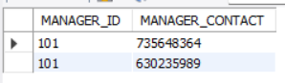

**#3.INSERTING VALUES INTO MANAGER_DEALER TABLE...**

INSERT INTO MANAGER_DEALER VALUES(101,1001);

INSERT INTO MANAGER_DEALER VALUES(101,1002);

INSERT INTO MANAGER_DEALER VALUES(101,1003);

INSERT INTO MANAGER_DEALER VALUES(101,1004);

INSERT INTO MANAGER_DEALER VALUES(101,1005);

INSERT INTO MANAGER_DEALER VALUES(101,1006);

INSERT INTO MANAGER_DEALER VALUES(101,1007);

INSERT INTO MANAGER_DEALER VALUES(101,1008);

INSERT INTO MANAGER_DEALER VALUES(101,1009);

INSERT INTO MANAGER_DEALER VALUES(101,1010);

INSERT INTO MANAGER_DEALER VALUES(101,1011);

SELECT * FROM MANAGER_DEALER;

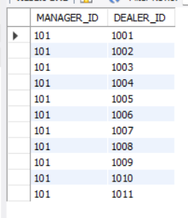

**#4.INSERTING VALUES INTO CUSTOMER TABLE...**

INSERT INTO CUSTOMER VALUES(1,'Shaik','Azaj','Uddin','Mangalagiri','Vijayawada','Male','Andhra Pradesh');

INSERT INTO CUSTOMER VALUES(2,'Shaik','Faahim','Uddin','Madanapalle','Chittoor','Male','Andhra Pradesh');

INSERT INTO CUSTOMER VALUES(3,'Puttaparti','Sai','Venkat','Palamneru','Chittoor','Male','Andhra Pradesh');

INSERT INTO CUSTOMER VALUES(4,'Yugi','Yugandhar','Reddy','Vallikavu','Kerala','Male','Kerala');

INSERT INTO CUSTOMER VALUES(5,'Kadiyala','Jaya','Prakash','Gannavaram','Vijayawada','Male','Andhra Pradesh');

INSERT INTO CUSTOMER VALUES(6,'Desu','Nithin','Datta','Chakraya Palem','Addanki','Male','Andhra Pradesh');

INSERT INTO CUSTOMER VALUES(7,'Chowdary','Chandra','Sekhar','Benz Circle','Vijayawada','Male','Andhra Pradesh');

INSERT INTO CUSTOMER VALUES(8,'Shaik','Arbaz','Uddin','Mahal','Rayachoty','Male','Andhra Pradesh');

INSERT INTO CUSTOMER VALUES(9,'Shaik','Shanawaz','Uddin','Nimmana Palle','Tirupati','Male','Andhra Pradesh');

INSERT INTO CUSTOMER VALUES(10,'Shaik','Shuaib','Akthar','Punganur','Chittoor','Male','Andhra Pradesh');

INSERT INTO CUSTOMER VALUES(11,'Shaik','Nathik','Basha','Kallur','Rayalaseema','Male','Andhra Pradesh');

SELECT * FROM CUSTOMER;

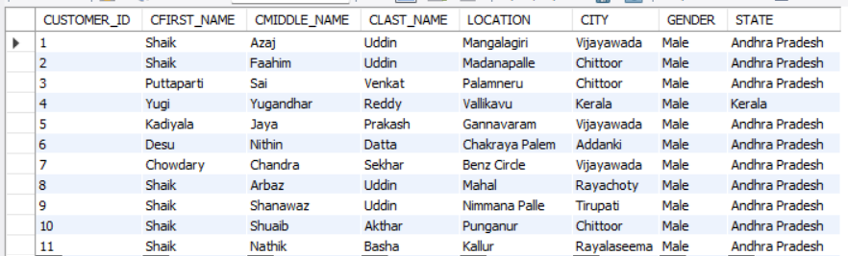

**#5.INSERTING VALUES INTO CUSTOMER_CONTACT TABLE...**

INSERT INTO CUSTOMER_CONTACT VALUES(1,74689269);

INSERT INTO CUSTOMER_CONTACT VALUES(1,27903480);

SELECT * FROM CUSTOMER_CONTACT;

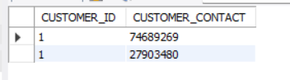

**#6.INSERTING VALUES INTO CUSTOMER_EMAILID TABLE...**

INSERT INTO CUSTOMER_EMAILID VALUES(1,'faahim@gmail.com');

INSERT INTO CUSTOMER_EMAILID VALUES(1,'faahim9@gmail.com');

INSERT INTO CUSTOMER_EMAILID VALUES(3,'sai@gmail.com');

INSERT INTO CUSTOMER_EMAILID VALUES(3,'venkat@gmail.com');

SELECT * FROM CUSTOMER_EMAILID;

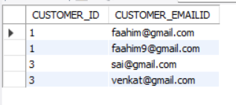

**#7.INSERTING VALUES INTO DEALER TABLE...**

INSERT INTO DEALER VALUES(1001,101,'GT-650','Chowdary','Sai','Vignesh','SBI-Coloney','Madanapalle','Andhra Pradesh','Male');

INSERT INTO DEALER VALUES(1002,101,'RC200','Pulivarthi','Vishnu','Vardhan','Eshwaramma-coloney','Madanapalle','Andhra Pradesh','Male');

INSERT INTO DEALER VALUES(1003,101,'Duke200','chowdary','Sai','Reddy','Drivers-Coloney','Madanapalle','Andhra Pradesh','Male');

INSERT INTO DEALER VALUES(1004,101,'Mustang','Chowdary','Sai','Vignesh','SBI-Coloney','Mumbai','Maharashtra','Male');

INSERT INTO DEALER VALUES(1005,101,'Dodge Challenger','Shaik','Nijam','Uddin','Market-Yard','Mumbai','Maharashtra','Male');

INSERT INTO DEALER VALUES(1006,101,'Mahindra Thar','Konidela','Pavan','kalyan','Market-Yard','Hyderabad','Telangana','Male');

INSERT INTO DEALER VALUES(1007,101,'Mahindra XUV700','Shaik','Jaffru','Uddin','Drivers-Coloney','Hyderabad','Telangana','Male');

INSERT INTO DEALER VALUES(1008,101,'MG-Hector','Syed','Dawood','Basha','Chipli','Madanapalle','Andhra Pradesh','Male');

INSERT INTO DEALER VALUES(1009,101,'Maruti Suzuki','Syed','Salis','Bukhari','Prashanth-Nagar','Kadapa','Andhra Pradesh','Male');

INSERT INTO DEALER VALUES(1010,101,'Creta','Syed','Kashif','Khan','Marpuri','Piler','Andhra Pradesh','Male');

INSERT INTO DEALER VALUES(1011,101,'Fortuner','Syed','Anees','Ahmed','Pakala','Chittoor','Andhra Pradesh','Male');

SELECT * FROM DEALER;

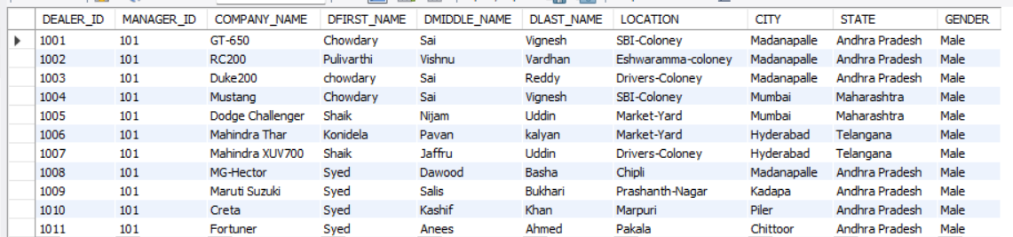

**#8.INSERTING VALUES INTO DEALER_CONTACT TABLE...**

INSERT INTO DEALER_CONTACT VALUES(1001,279038349);

INSERT INTO DEALER_CONTACT VALUES(1001,279543429);

SELECT * FROM DEALER_CONTACT;

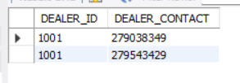

**#9.INSERTING VALUES INTO TAX TABLE...**

INSERT INTO TAX VALUES(1000,110,'ALL_TAX',50042,'PENDING');

INSERT INTO TAX VALUES(2000,120,'ROAD_TAX',500000,'PENDING');

INSERT INTO TAX VALUES(3000,130,'ALL_TAX',54200,'CLEAR');

INSERT INTO TAX VALUES(4000,140,'INSU_TAX',533000,'CLEAR');

INSERT INTO TAX VALUES(5000,150,'ALL_TAX',5412,'PENDING');

SELECT * FROM TAX;

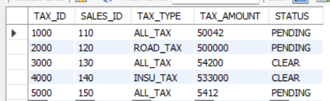

**#10.INSERTING VALUES INTO VEHICLE TABLE...**

INSERT INTO VEHICLE VALUES(12131,1001,'Duke250','D250','BIKE','Sports Bike',250000,'2022-6-10','AVAILABLE');

INSERT INTO VEHICLE VALUES(12647,1002,'RC250','RC250','BIKE','Sports Bike',25000,'2022-7-13','AVAILABLE');

INSERT INTO VEHICLE VALUES(13593,1003,'RX-100','RX125','BIKE','TwoStroke ',70000,'2022-1-22','SOLD_OUT');

INSERT INTO VEHICLE VALUES(19074,1004,'AUDI','A414','CAR','Luxury Car','6542000','2021-7-22','AVAILABLE');

INSERT INTO VEHICLE VALUES(14361,1005,'RollsRoyce','RR7861','CAR','Luxury Car',65000000,'2021-12-2','SOLD_OUT');

INSERT INTO VEHICLE VALUES(14362,1006,'RollsRoyce','RR7862','CAR','Luxury Car',65000000,'2021-12-2','SOLD_OUT');

INSERT INTO VEHICLE VALUES(14363,1005,'Dodge Challenger','DG7863','CAR','Luxury Car',65000000,'2021-12-2','SOLD_OUT');

INSERT INTO VEHICLE VALUES(14364,1005,'Classic350','C7864','Bike','Normal-Bike',350000,'2021-12-2','SOLD_OUT');

INSERT INTO VEHICLE VALUES(14365,1009,'Yamaha-Y1','YY7865','Bike','Normal-Bike',250000,'2021-12-2','SOLD_OUT');

INSERT INTO VEHICLE VALUES(14366,1003,'Splender','SP7866','Bike','Ordinary Bike',50000,'2021-12-2','SOLD_OUT');

INSERT INTO VEHICLE VALUES(14367,1003,'RollsRoyce','RR7867','CAR','Luxury Car',95000000,'2021-12-2','AVAILABLE');

SELECT * FROM VEHICLE;

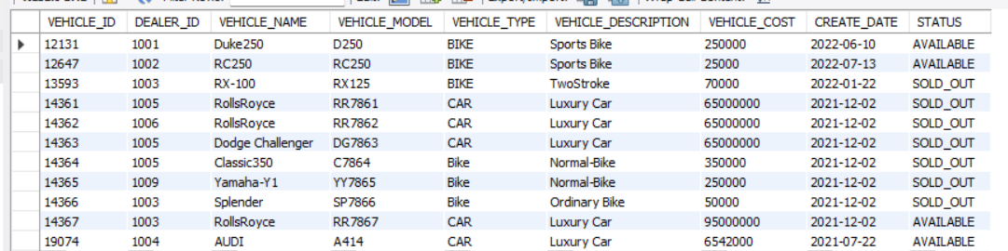

**#11.INSERTING VALUES INTO SHOWROOM TABLE...**

INSERT INTO SHOWROOM VALUES(1101,1001,'Faiyaj Shaik','MADANAPALLE','Andhra Pradesh','FULL');

SELECT * FROM SHOWROOM;



**#12.INSERTING VALUES INTO SHOWROOM_CONTACT TABLE...**

INSERT INTO SHOWROOM_CONTACT VALUES(1101,65763349);

INSERT INTO SHOWROOM_CONTACT VALUES(1101,78943429);

SELECT * FROM SHOWROOM_CONTACT;

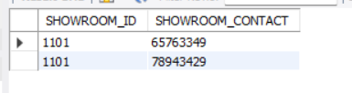

**#13.INSERTING VALUES INTO DEALER_SHOWROOM TABLE...**

INSERT INTO DEALER_SHOWROOM VALUES(1001,1101);

INSERT INTO DEALER_SHOWROOM VALUES(1001,1101);

INSERT INTO DEALER_SHOWROOM VALUES(1001,1101);

INSERT INTO DEALER_SHOWROOM VALUES(1001,1101);

INSERT INTO DEALER_SHOWROOM VALUES(1001,1101);

INSERT INTO DEALER_SHOWROOM VALUES(1001,1101);

INSERT INTO DEALER_SHOWROOM VALUES(1001,1101);

INSERT INTO DEALER_SHOWROOM VALUES(1001,1101);

INSERT INTO DEALER_SHOWROOM VALUES(1001,1101);

INSERT INTO DEALER_SHOWROOM VALUES(1001,1101);

INSERT INTO DEALER_SHOWROOM VALUES(1001,1101);

SELECT * FROM DEALER_SHOWROOM;

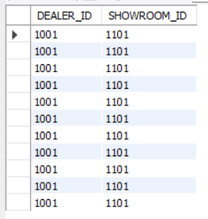

**#14.INSERTING VALUES INTO SALES TABLE...**

INSERT INTO SALES VALUES(110,12131,1,1101,45000,'Madanapalle','AndhraPradesh','2022-3-19','2022-6-29','SUPER');

INSERT INTO SALES VALUES(120,12647,2,1101,85000,'Kadapa','Andhra Pradesh','2020-6-21','2020-10-10','MEDIUM');

INSERT INTO SALES VALUES(130,13593,3,1101,70000,'Piler','Andhra Pradesh','2019-1-10','2019-3-23','AVERAGE');

INSERT INTO SALES VALUES(140,19074,4,1101,805000,'Chittoor','Andhra Pradesh','2020-4-7','2020-5-9','SUPER');

INSERT INTO SALES VALUES(150,14365,7,1101,155000,'Hyderabad','Telangana','2022-7-2','2018-8-7','MEDIUM');

SELECT * FROM SALES;

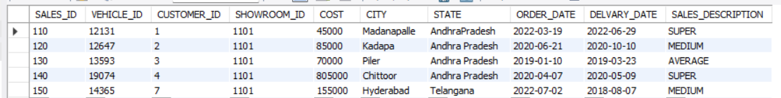

**#15.INSERTING VALUES INTO BILLING TABLE...**

INSERT INTO BILLING VALUES(123,101,'2017-2-14',60000,2000);

INSERT INTO BILLING VALUES(124,101,'2015-9-21',43500,3342);

INSERT INTO BILLING VALUES(125,101,'2019-12-3',110000,8567);

INSERT INTO BILLING VALUES(126,101,'2020-11-30',65400000,45568);

INSERT INTO BILLING VALUES(127,101,'2021-6-9',5670000,35524);

INSERT INTO BILLING VALUES(128,101,'2022-2-19',987000,4352);

INSERT INTO BILLING VALUES(129,101,'2022-7-27',3060000,23000);

SELECT * FROM BILLING;

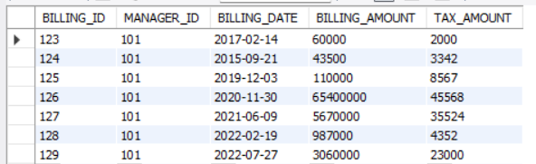

**#16.INSERTING VALUES INTO BOOKING TABLE...**

INSERT INTO BOOKING VALUES(9871,'2020-3-23',1,'Loan',498035,'Online Payment');

INSERT INTO BOOKING VALUES(9872,'2022-4-14',2,'Paid',479829,'Direct Booking');

INSERT INTO BOOKING VALUES(9873,'2020-9-19',3,'Paid',879369,'Online Payment');

INSERT INTO BOOKING VALUES(9874,'2021-1-31',4,'Loan',386578,'Direct Booking');

INSERT INTO BOOKING VALUES(9875,'2021-8-18',5,'Loan',900000,'Online Payment');

INSERT INTO BOOKING VALUES(9876,'2021-2-20',6,'Loan',950000,'Online Payment');

INSERT INTO BOOKING VALUES(9877,'2020-5-15',7,'Paid',1000000,'Online Payment');

INSERT INTO BOOKING VALUES(9878,'2020-7-17',8,'Loan',2400000,'Direct Booking');

INSERT INTO BOOKING VALUES(9879,'2021-11-30',9,'Loan',650000,'Online Payment');

INSERT INTO BOOKING VALUES(9870,'2020-6-21',10,'Paid',345000,'Online Payment');

INSERT INTO BOOKING VALUES(9869,'2021-12-11',11,'Loan',790005,'Direct Booking');

SELECT * FROM BOOKING;

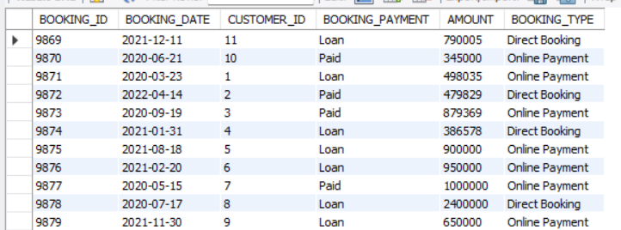

**#17.INSERTING VALUES INTO PAYMENT TABLE...**

INSERT INTO PAYMENT VALUES(901,1,'2020-6-11',1250000,'CASH_PAYMENT','DUE');

INSERT INTO PAYMENT VALUES(902,2,'2022-6-21',5550000,'ONLINE_PAYMENT','DUE');

INSERT INTO PAYMENT VALUES(903,3,'2020-12-31',6250000,'ONLINE_PAYMENT','CLEARED');

INSERT INTO PAYMENT VALUES(904,4,'2020-7-17',8250000,'ONLINE_PAYMENT','CLEARED');

INSERT INTO PAYMENT VALUES(905,5,'2021-9-27',2250000,'ONLINE_PAYMENT','DUE');

INSERT INTO PAYMENT VALUES(906,6,'2021-8-24',3250000,'CASH_PAYMENT','DUE');

INSERT INTO PAYMENT VALUES(907,7,'2020-2-12',6250000,'ONLINE_PAYMENT','CLEARED');

INSERT INTO PAYMENT VALUES(908,8,'2020-3-11',4250000,'CASH_PAYMENT','DUE');

INSERT INTO PAYMENT VALUES(909,9,'2021-5-15',9250000,'ONLINE_PAYMENT','CLEARED');

INSERT INTO PAYMENT VALUES(910,10,'2020-9-19',250000,'CASH_PAYMENT','DUE');

INSERT INTO PAYMENT VALUES(911,11,'2021-6-16',350000,'CASH_PAYMENT','DUE');

SELECT * FROM PAYMENT;

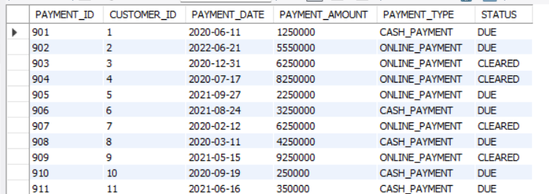

**#18.INSERTING VALUES INTO WORKER TABLE...**

INSERT INTO WORKER VALUES(701,1101,'Receptionist','Shaik','Aasma','Khan',10000,'Good','Female');

INSERT INTO WORKER VALUES(702,1101,'Sales Manager','Shaik','Nawaz','Basha',50000,'Average','Male');

INSERT INTO WORKER VALUES(703,1101,'Car Mechanic','Shaik','Nayaz','Khan',20000,'Good','Male');

INSERT INTO WORKER VALUES(704,1101,'Bike Mechanic','Shaik','Abdullah','Khan',10000,'Good','Male');

INSERT INTO WORKER VALUES(705,1101,'Accountant','Shaik','Tanweer','Ulla',15000,'Good','Male');

SELECT * FROM WORKER;

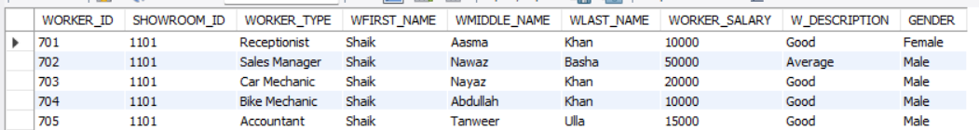

**#18.INSETING VALUES INTO WORKER_CONTACT TABLE...**

INSERT INTO WORKER_CONTACT VALUES(701,247658296);

INSERT INTO WORKER_CONTACT VALUES(701,907658296);

SELECT * FROM WORKER_CONTACT;

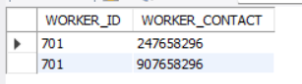

3.1 SQL Queries:

--------------------------------------------------------------#QUERIES-------------------------------------------------------------------------

**#1) SELECT ALL THE VEHICLE NAMES WHERE VEHICLE TYPE IS BIKE...**

SELECT ALL VEHICLE_NAME

from VEHICLE

WHERE VEHICLE_TYPE = 'BIKE';

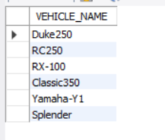

**#2) LIST ALL THE CUSTOMER NAMES WHO ORDERED VEHICLES ON DATE 16-JAN- 2016…**

SELECT CUSTOMER.CMIDDLE_NAME

FROM CUSTOMER , SALES

WHERE SALES.CUSTOMER_ID=CUSTOMER.CUSTOMER_ID AND ORDER_DATE='2022-3-19';

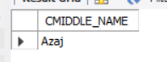

**#3) LIST THE VEHICLE_NAME WHICH HAS HIGHEST COST AMONG ALL THE VEHICLES…**

SELECT VEHICLE_NAME,MAX(VEHICLE_COST)

FROM VEHICLE

WHERE VEHICLE_TYPE = 'CAR';



**#4) LIST THE VEHICLE_NAME WHICH HAS LOWEST COST AMONG ALL THE VEHICLES…**

SELECT VEHICLE_NAME, MIN(VEHICLE_COST)

FROM VEHICLE

WHERE VEHICLE_TYPE = 'Bike';

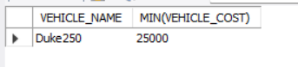

**#5) LIST ALL THE SHOWROOM NAMES THAT COMES UNDER DEALER ID=1001…**

SELECT SHOWROOM.SHOWROOM_NAME,DEALER.DEALER_ID

FROM SHOWROOM , DEALER

WHERE SHOWROOM.DEALER_ID=DEALER.DEALER_ID AND DEALER.DEALER_ID=1001;

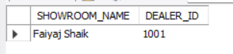

**#6.IF THE CUSTOMER WANTS TO SEE ALL THE VEHICLES AVAILABLE IN TH SHOWROOM...**

select * from VEHICLE where VEHICLE_ID in(

select VEHICLE_ID from SALES

where (SALES_ID

in (select SALES_ID from CUSTOMER where CUSTOMER_ID='11')) and STATUS ='AVAILABLE');



**#7.IF A CUSTOMER WANTS TO SEE THE ORDER HISTORY OF VEHICLES ORDERD BY WHICH CUSTOMER AND WITH VEHICLE COST...**

SELECT ORDER_DATE,VEHICLE_NAME,CMIDDLE_NAME,VEHICLE_COST

FROM SALES,VEHICLE,CUSTOMER

WHERE SALES.VEHICLE_ID = VEHICLE.VEHICLE_ID AND SALES.CUSTOMER_ID = CUSTOMER.CUSTOMER_ID;

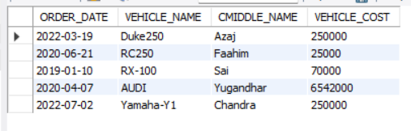

# Concluding Remarks

A description of the background and context of the project and its relation to work already done in the area. Made statement of the aims and objectives of the project. The description of Purpose, Scope, and applicability. I have defined the problem on which I had worked in the project. I have described the requirement Specifications of the system and the actions that can be done on these things. I had understood the problem domain and produce a model of the system, which describes operations that can be performed on the system. I have included the features and operations in detail, including screen layouts.

# Future Work

Today, the market place is flooded with several vehicle showroom options for shoppers to choose from. A variety of innovative products and services are being offered spoiling customers for choice. Online vehicle showroom system is no more a privilege enjoyed by your friends and family. Today, it is a reality in India. In the last couple of years, the growth of vehicle showroom system industry in India has been phenomenal as more shoppers have started discovering the benefits of using this platform. There is enough scope for online businesses in the future if they understand the Indian shoppers psyche and cater to their needs. So, I would like to develop a webpage for this project in the coming days.

# References

1. <https://github.com/topics/vehicle-management-system>
2. <https://www.javatpoint.com/transport-company-project>
3. <https://www.youtube.com/watch?v=z_aZafgno38>
4. <https://github.com/topics/dbms-project>
5. <https://projectsgeek.com/dbms-project-ideas-top-free>
6. <https://getsetproject.com/projects.php?navSend=Mini-Dbms>
7. https://www.geeksforgeeks.org/10-best-sql-project-ideas-for-beginners/